Madonna – Material Girl
YAM:WINT T22: Chimes KORG: BUZZ and PICK
Intro | Bass riff (4)  Add chimes (4)  Add melody (8)
Verse | 8 twice
Chorus | 7 with melody (elision)  4 intro melody (changed)
Verse 1:18 | 8 twice
Chorus 1:46 | 7 with melody  ½ intro melody  7 with melody  8 intro melody
Chant Interlude | 8
Verse | 8
Chorus | 7 with melody  ½ intro melody  7 with melody  2 intro melody, break
Echo section | 4
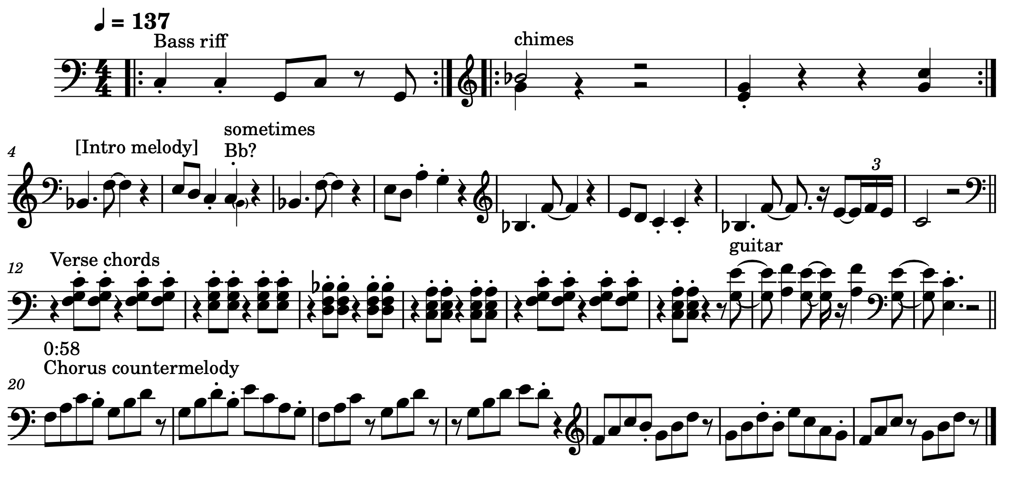  Chant Interlude | 8 to fade

